Network PDU-S High Level Design Document

Introduction and Features
The Network PDU-S is a product that combines several features into a single package
- Power Distribution through two front and six rear outlets
- Surge protection and line filtering
- Network control of each outlet via a web page.
- Programmable sequencer so outlets can be turned on/off in a specific order after a configurable delay.

The Network PDU-S will come in a 19” rack mount case that is standard for the Audio/Visual and Information Technology industries.

Top Level Architecture
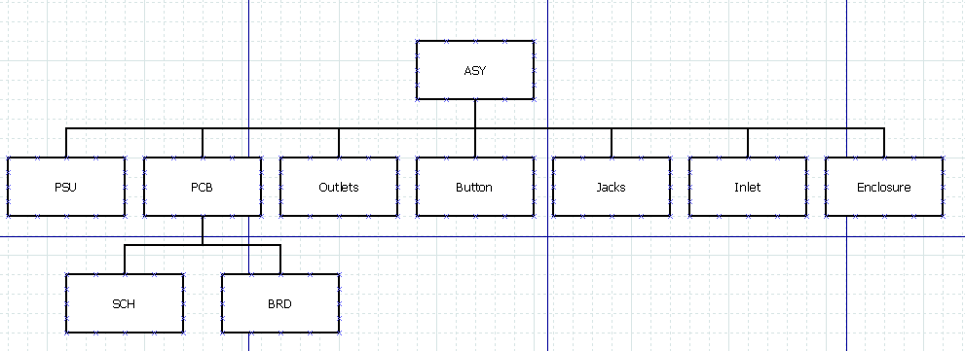

Software Tools
This project will take advantage of multiple CAD tools:
- Kicad
  - PCB EDA Suite
  - Free, Open Source Software
- Solidworks
  - Mechanical Part and Assembly Design
  - Proprietary Software
- Arduino Code Libraries
  - Free, Open Source Software
- AVR-GCC
  - Compiler provided by Atmel
- C++ Language
- Gantt Project
  - Project Management
  - Free, Open Source Software
- DIA
  - Diagraming tool
  - Free, Open Source Software

Hardware Tools
- Rigol Oscilloscope
- Fluke 87V Multimeter
- Kitchen Hot Plate
- Hakko Soldering Iron
- Brainbox RS232 to Ethernet adapter
- Current Limiting Bench Power Supply

Vendors
This project will use several vendors to manufacture the parts and final assembly:
- Protocase for the rackmount enclosure
- Digikey for the electronics BOM
- OSHPark for the PCB
- OSHStencils for the solder paste stencil
- Hand Assembly for the top level.

